This imports Microsoft's public key into your system's trusted keyring so dnf can verify VS Code packages come from Microsoft.
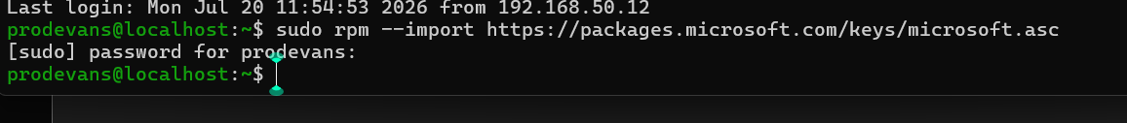
This creates a repo definition file so dnf knows where to find and download VS Code packages.
Then second code is to verify wheather it worked or not
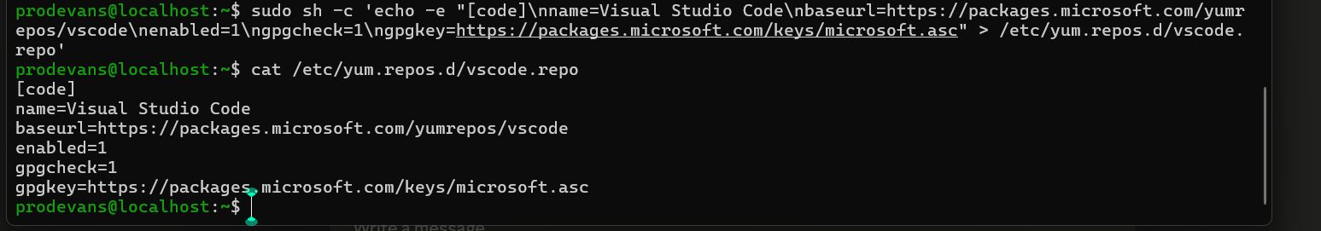
Refreshing package metadata and installing it :
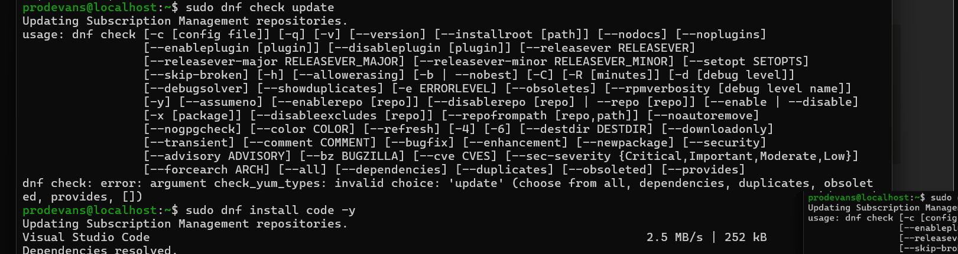
Then we are confirming it wheather it got downloaded or not :
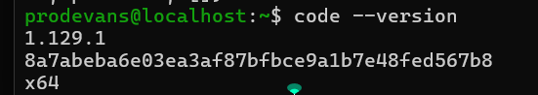
Then after that we need to provide the code and make sure that you type it on the rhel machine not on ssh:
:code
Then we are installing the essential packages:
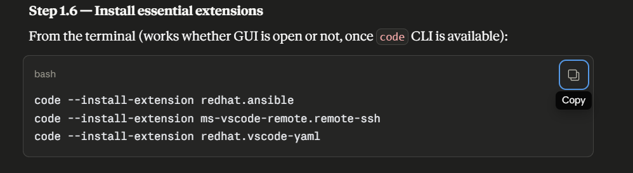
How to connect the laptop vs code to the control node :
1.open vs code and then install the extension remote-ssh by Microsoft
2.type ctrl + shift + p then
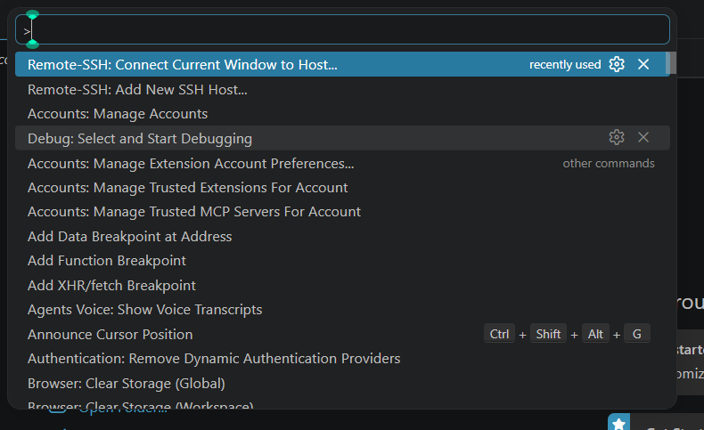
Choose the second option add new ssh
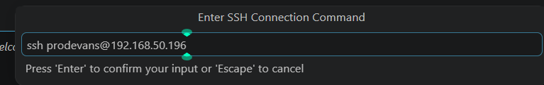
Then choose the first option this is where your details was saved:
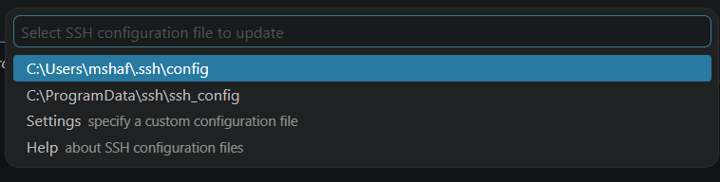
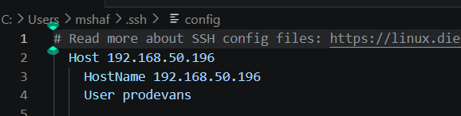
Then save the file and hold ctrl+shift+P
Choose the first option
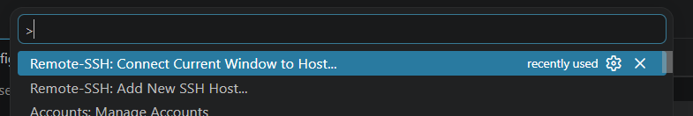
Choose the alias name what you had typed during setting the config file then provide the password now it is successfully connected :
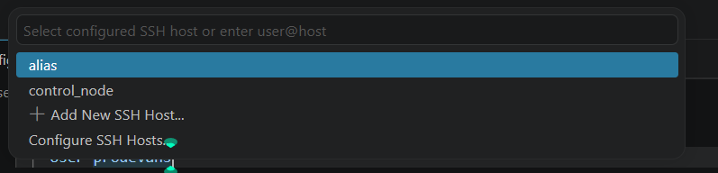
Then we are connected to the control node after whatever files we are browsing we are doing it in control node folders .

